UNIT-V
Cluster Analysis

Cluster analysis divides data into meaningful or useful groups or both. These are called as “clusters”.

Cluster analysis played an important role in a wide variety of fields: psychology and other social sciences, biology, statistics, pattern recognition, information retrieval, machine learning, and data mining.

What Is Cluster Analysis?

Cluster analysis groups data objects based only on information found in the data that describes the objects and their relationships.

The goal is that the objects within a group be similar or related to one another in the same group and different from or unrelated to the objects in other groups.

Figure 8.1, which show 20 points and 3 different ways of dividing them into clusters.

The shapes of the markers indicate cluster membership.

Figures 8.1(b) and 8.1(d) divide the data into two and six parts, respectively.

The two larger clusters are divided each of into three sub clusters.

Clustering approach is also called as unsupervised classification.

The terms segmentation and partitioning are sometimes used as synonyms for clustering.

These terms are frequently used for approaches outside the traditional bounds of cluster analysis.

For example, the term partitioning is often used in connection with techniques that divide graphs into sub-graphs.

Segmentation often refers to the division of data into groups using simple techniques;

For e.g.: an image can be split into segments based only on pixel intensity and color, or people can be divided into groups based on their income.

Different Types of Clustering’s:

An entire collection of clusters is commonly referred to as a clustering.

We distinguish various types of clusterings:

- Hierarchical (nested) clustering.
- Partitional (unnested) clustering.
- Exclusive clustering.
- Overlapping clustering.
- Fuzzy clustering.
- Complete clustering.
- Partial clustering.

Hierarchical versus Partitional:

Partitional clustering is simply a division of the set of data objects into non-overlapping subsets (or clusters) such that each data object is in exactly one subset.

Each collection of clusters in Figures from (b-to-d) is a partitional clustering.

If, clusters to have sub-clusters, then we obtain a hierarchical clustering, which is a set of nested clusters that are organized as a tree.

Each node (cluster) in the tree (except for the leaf nodes) is the union of its children (sub-clusters), and the root of the tree is the cluster containing all the objects.

A hierarchical clustering can be viewed as a sequence of partitional clusterings.

A partitional clustering can be obtained by taking any member of that sequence; i.e., by cutting the hierarchical tree at a particular level.

Exclusive versus Overlapping versus Fuzzy:

The clusterings shown in Figure 8.1 are all “Exclusive clustering”, as they assign each object to a single cluster.

There are many situations in which a point could reasonably be placed in more than one cluster.
These situations are better addressed by non-exclusive clustering.

In the most general sense, an overlapping or non-exclusive clustering is used to reflect the fact that an object can simultaneously belong to more than one group (class).

For instance, a person at a university can be both an enrolled student and an employee of the university.

In a fuzzy clustering, every object belongs to every cluster with a membership weight that is between 0 (absolutely doesn’t belong) and 1 (absolutely belongs).

In other words, clusters are treated as fuzzy sets.

Mathematically, a fuzzy set is one in which an object belongs to any set with a weight that is between 0 and 1.

In fuzzy clustering, we often impose the additional constraint that the sum of the weights for each object must equal 1.

Similarly, probabilistic clustering techniques compute the probability with which each point belongs to each cluster, and these probabilities must also sum to 1.

A fuzzy or probabilistic clustering is often converted to an exclusive clustering by assigning each object to the cluster in which its membership weight or probability is highest.

Complete versus partial clustering:

A complete clustering assigns every object to a cluster, whereas a partial clustering does not.

A complete clustering of the objects is desired.

For example, an application that uses clustering to organize documents for browsing needs to guarantee that all documents can be browsed.

The motivation for a partial clustering is that some objects in a data set may not belong to well-defined groups.

Many times objects in the data set may represent noise, outliers, or “uninteresting background.”

Different Types of Clusters:

The aim of Clustering is to find useful groups of objects or clusters, where usefulness is defined by the goals of the data analysis.

In order to visually illustrate the differences among these types of clusters, we use two dimensional points, as shown in Figure 8.2, as our data objects.

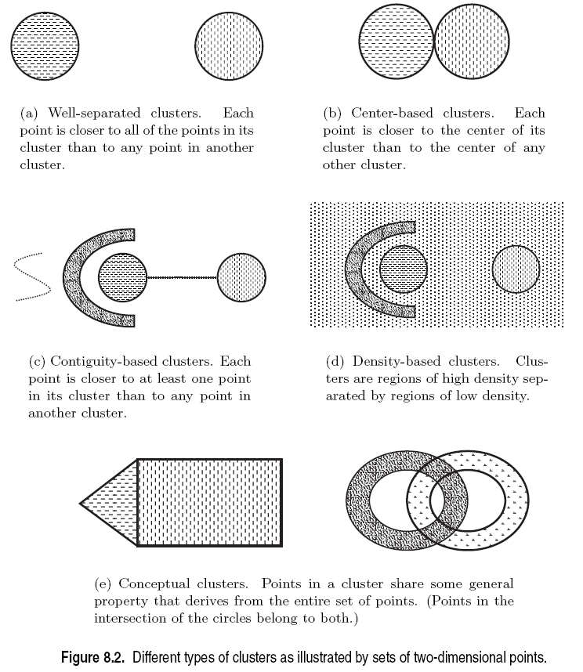

Types of clusters are:

- Well-Separated Clusters.
- Prototype-Based or center-based clusters.
- Graph-Based or contiguity-based clusters.
- Density-Based clusters.
- Conceptual Clusters.

Well-Separated cluster:

It is a set of objects in which each object is closer (or more similar) to every other object in the cluster than to any object not in the cluster.

Sometimes a threshold is used to specify that all the objects in a cluster must be sufficiently close (or similar) to one another.

Figure 8.2(a) gives an example of well-separated clusters that consists of two groups of points in a two-dimensional space.

The distance between any two points in different groups is larger than the distance between any two points within a group.

Prototype-Based cluster:

A cluster is a set of objects in which each object is closer (more similar) to the prototype that defines the cluster than to the prototype of any other cluster.

For data with continuous attributes, the prototype of a cluster is often a centroid, i.e., the average (mean) of all the points in the cluster.

When a centroid is not meaningful, such as when the data has categorical attributes, the prototype is often a medoid, i.e., the most representative point of a cluster.

We commonly refer to prototype- based clusters as center-based clusters. Figure 8.2(b) shows an example of center-based clusters.

Graph-Based cluster:

If the data is represented as a graph, where the nodes are objects and the links represent connections among objects then a cluster can be defined as a connected component.

That means a group of objects that are connected to one another, but that have no connection to objects outside the group.

Important examples of graph-based clusters are contiguity based clusters, where two objects are connected only if they are within a specified distance of each other.

This implies that each object in a contiguity-based cluster is closer to some other object in the cluster than to any point in a different cluster.
Figure 8.2(c) shows an example of such clusters for two-dimensional points.

Other types of graph-based clusters are also possible. One such approach defines a cluster as a clique ; i.e., a set of nodes in a graph that are completely connected to each other.

Specifically, if we add connections between objects in the order of their distance from one another, a cluster is formed when a set of objects forms a clique.

Both prototype-based clusters, such clusters tend to be globular.
Density-Based cluster:

A cluster is a dense region of objects that is surrounded by a region of low density.

Figure 8.2(d) shows some density-based clusters for data created by adding noise to the data of Figure 8.2(c).

A density-based definition of a cluster is often employed when the clusters are irregular or intertwined, and when noise and outliers are present.

Shared-Property Conceptual Clusters:

More generally, we can define a cluster as a set of objects that share some property.

The shared-property approach also includes new types of clusters.

Consider the clusters shown in Figure 8.2(e). A triangular area (cluster) is adjacent to a rectangular one, and there are two intertwined circles (clusters).

In both cases, a clustering algorithm would need a very specific concept of a cluster to successfully detect these clusters. The process of finding such clusters is called conceptual clustering.

The following three simple, but important techniques to introduce many of the concepts involved in cluster analysis.

- K-means.

- Agglomerative Hierarchical Clustering.

- DBSCAN

TOPIC: K-means:

K-means: This is a prototype-based, partitional clustering technique that attempts to find a user-specified number of clusters (K ), which are represented by their centroids.

Centroid is the average (mean) of all the points in the cluster.

For data with continuous attributes, the prototype of a cluster is often a centroid.

Prototype-based clustering techniques create a one-level partitioning of the data objects.

There are a number of such techniques, but two of the most prominent are:
- K-means.
- K-medoid.

We will focus only on K-means, which is one of the oldest and most widely used clustering algorithms.

K-means defines a prototype in terms of a centroid, which is usually the mean of a group of points, and is typically applied to objects in a continuous n-dimensional space.

Topic: The Basic K-means Algorithm:

We first choose K initial centroids, where K is a user-specified parameter, namely, the number of clusters desired.
Each point is then assigned to the closest centroid (center point of the cluster).

Each collection of points assigned to a centroid is a cluster.

The centroid of each cluster is then updated based on the points assigned to the cluster.

We repeat the assignment and update steps until no point changes clusters, or equivalently, until the centroids remain the same.

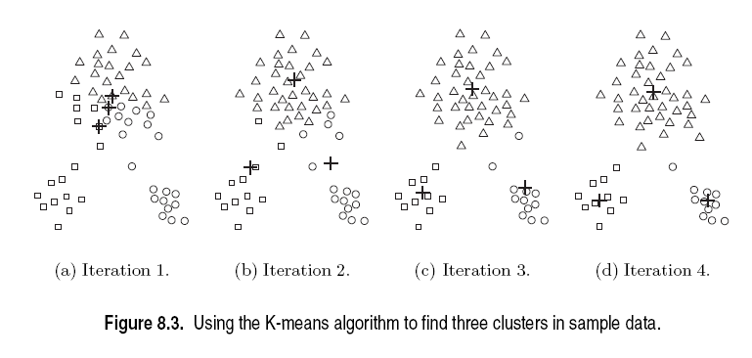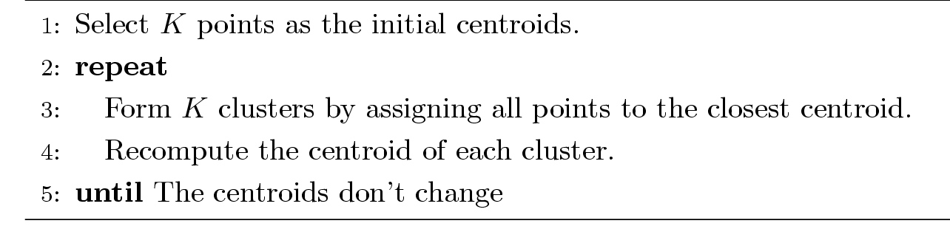

The operation of K-means is illustrated in Figure 8.3.

It is starting from three centroids, the final clusters are found in four assignment-update steps.

In these and other figures displaying K-means clustering, each subfigure shows:
- The centroids at the start of the iteration.
- The assignment of the points to those centroids.

The centroids are indicated by the “+” symbol; all points belonging to the same cluster have the same marker shape.

In the first step, shown in Figure 8.3(a), points are assigned to the initial centroids, which are all in the larger group of points.

For this example, we use the “mean” as the centroid.

After points are assigned to a centroid, the centroid is then updated.

Again, the figure for each step shows the centroid at the beginning of the step and the assignment of points to those centroids.

In the second step, points are assigned to the updated centroids, and the centroids are updated again.

In steps 2, 3, and 4, which are shown in Figures 8.3 (b),(c), and (d), respectively, two of the centroids move to the two small groups of points at the bottom of the figures.

When the K means algorithm terminates in Figure 8.3(d), because no more changes occur, the centroids have identified the natural groupings of points.

The algorithm repeatedly calculates the similarity of each point to each centroid.

K-means reaches a state in which no points are shifting from one cluster to another, and hence, the centroids don’t change.

We consider each of the steps in the basic K-means algorithm in more detail and then provide an analysis of the algorithm’s space and time complexity.

- Assigning Points to the Closest Centroid:

To assign a point to the closest centroid, we need a proximity measure of “closest” for the specific data.

- Euclidean (L₂) distance is often used for data points in Euclidean space.
- Cosine similarity is more appropriate for documents.
- Manhattan (L₁) distance can be used for Euclidean data.
- The Jaccard measure is often employed for documents.

The above 4 types are proximity measures are used for K-mean algorithm to calculate the “similarity/ dissimilarity” of points with respect to centroid.

- Centroids and Objective Functions:

Step 4 of the K-means algorithm was stated rather generally as “recompute the centroid of each cluster,” since the centroid can vary, depending on the proximity measure for the data and the goal of the clustering.

The goal of the clustering is typically expressed by an objective function that depends on the proximities of the points to one another or to the cluster centroids;

- Data in Euclidean Space:

If, we consider data whose proximity measure is Euclidean distance.

For our objective function, which measures the quality of a clustering, we use the “sum of the squared error (SSE)”, which is also known as scatter.

\In other words, we calculate the error of each data point, i.e., its Euclidean distance to the closest centroid, and then compute the total sum of the squared errors.

The SSE is formally defined as follows:

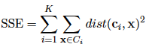

The centroid (mean) of the i^{th} cluster is defined by the following Equation:

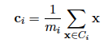

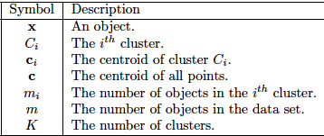

To illustrate, the centroid of a cluster containing the three two-dimensional points, (1,1), (2,3), and (6,2), is ((1 + 2 + 6)/3, ((1+3+2)/3) = (3, 2).

- Document Data:

To illustrate that K-means is not restricted to data in Euclidean space, we consider document data and the cosine similarity measure.

The document data is represented as a document-term matrix.

Our objective is to maximize the similarity of the documents in a cluster to the cluster centroid.
This quantity is known as the “cohesion” of the cluster.

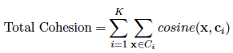

- The General Case:

There are a number of choices for the proximity function, centroid, and objective function that can be used in the basic K-means algorithm.

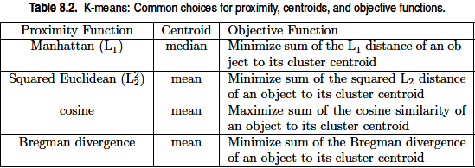

- Choosing Initial Centroids:

Choosing the proper initial centroids is the key step of the basic K-means procedure.

- A common approach is to choose the initial centroids randomly, but the resulting clusters are often poor.

- One effective approach is to take a sample of points and cluster them using a hierarchical clustering technique.

K clusters are extracted from the hierarchical clustering, and the centroids of those clusters are used as the initial centroids.

This approach often works well, but is practical only if (1) the sample is relatively small, (2) K is relatively small compared to the sample size.

- Another approach of selecting initial centroids is Select the first point at random or take the centroid of all points. Then, for each successive initial centroid, select the point that is farthest from any of the initial centroids already selected.

In this way, we obtain a set of initial Centroids not only randomly selected but also well separated.

Unfortunately, such an approach can select outliers. Also, it is expensive to compute the farthest point from the current set of initial centroids.

Time and Space Complexity:

The space requirements for K-means are modest because only the data points and centroids are stored.

Specifically, the storage required is:

O((m + K)n)

Where m is the number of points and n is the number of attributes.

The time required is:

O(I * K * m * n)

Where I is the number of iterations required for convergence. I is often in small size.

TOPIC: K-means: Additional Issues:

- Handling Empty Clusters:

One of the problems with the basic K-means algorithm given earlier is that empty clusters can be obtained if no points are allocated to a cluster during the assignment step.

If this happens, then a strategy is needed to choose a replacement centroid, otherwise, the squared error will be larger than necessary.

One approach is to choose the point that is farthest away from any current centroid.

Another approach is to choose the replacement centroid from the cluster that has the highest SSE.

This will typically split the cluster and reduce the overall SSE of the clustering.

If there are several empty clusters, then this process can be repeated several times.

- Outliers:

In particular, when outliers are present, the resulting cluster centroids (prototypes) may not be as representative. The SSE will be higher as well.

Because of this, it is often useful to discover outliers and eliminate them beforehand.

It is important, that there are certain clustering applications for which outliers should not be eliminated. When clustering is used for data compression, every point must be clustered.

If we use approaches that remove outliers before clustering, we avoid clustering points that will not cluster well.

Alternatively, outliers can also be identified in a post processing step.

For instance, we can keep track of the SSE contributed by each point, and eliminate those points with unusually high contributions.

- Reducing the SSE with Post processing:

Various techniques are used to “fix up” the resulting clusters in order to produce a clustering that has lower SSE.

The strategy is to focus on individual clusters; since, the total SSE is simply the sum of the SSE contributed by each cluster.

We can change the total SSE by performing various operations on the clusters, such as splitting or merging clusters.

One commonly used approach is to use alternate cluster splitting and merging phases. During a splitting phase, clusters are divided, while during a merging phase, clusters are combined.

In this way, it is often possible to escape local SSE minima and still produce a clustering solution with the desired number of clusters.

The following are some techniques used in the splitting and merging phases. Two strategies that decrease the total SSE by increasing the number of clusters are the following:

Split a cluster:

The cluster with the largest SSE is usually chosen, but we could also split the cluster with the largest standard deviation for one particular attribute.

Merge two clusters:

The clusters with the closest centroids are typically chosen, although another, perhaps better, approach is to merge the two clusters that result in the smallest increase in total SSE. These two merging strategies are the same ones that are used in the hierarchical clustering techniques known as the centroid method and Ward’s method.
- Updating Centroids Incrementally:

Instead of updating cluster centroids after all points have been assigned to a cluster, the centroids can be updated incrementally, after each assignment of a point to a cluster.

Notice that this requires either zero or two updates to cluster centroids at each step.

Since a point either move to a new cluster (two updates) or stays in its current cluster (zero updates).

Using an incremental update strategy guarantees that empty clusters are not produced.

Benefit of incremental updates has to do with using objectives other than “minimize SSE.”

Suppose that we are given an arbitrary objective function to measure the goodness of a set of clusters.

When we process an individual point, we can compute the value of the objective function for each possible cluster assignment, and then choose the one that optimizes the objective.

On the negative side, updating centroids incrementally introduces an order dependency.

In other words, the clusters produced may depend on the order in which the points are processed.

Also incremental updates are slightly more expensive.

Topic: Bisecting K-means:

The bisecting K-means algorithm is a straightforward extension of the basic K-means algorithm.

This is based on a simple idea:

To obtain K clusters, split the set of all points into two clusters, select one of these clusters to split, and so on, until K clusters have been produced.

The details of bisecting K-means are given by Algorithm 8.2.

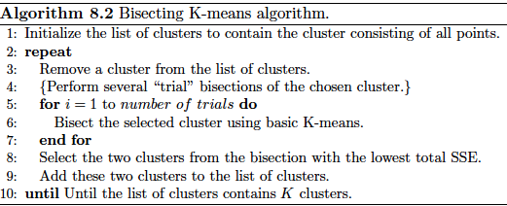

There are a number of different ways to choose which cluster to split.

We can choose the largest cluster at each step, choose the one with the largest SSE, or use a criterion based on both size and SSE.

Different choices result in different clusters.

The resulting clusters by using their centroids as the initial centroids for the basic K-means algorithm.

This is necessary because, although the K-means algorithm is guaranteed to find a clustering that represents a local minimum with respect to the SSE.

In bisecting K-means we are using the K- means algorithm “locally.” i.e., to bisect individual clusters.

Therefore, the final set of clusters does not represent a clustering that is a local minimum with respect to the total SSE.

Bisecting K-means and Initialization:

To illustrate that bisecting K-means is less susceptible to initialization problems, we show, in
Figure:

In iteration 1, two pairs of clusters are found.
In iteration 2, the rightmost pair of clusters is split.
In iteration 3, the leftmost pair of clusters is split.

Bisecting K-means has less trouble with initialization because it performs several trial bisections and takes the one with the lowest SSE, and because there are only two centroids at each step.

Finally, by recording the sequence of clusterings produced as K-means bisects clusters, we can also use bisecting K-means to produce a hierarchical clustering.

Topic: K-means and Different Types of Clusters

K-means and its variations have a number of limitations with respect to finding different types of clusters.

In particular, K-means has difficulty detecting the “natural” clusters, when clusters have non-spherical shapes or widely different sizes or densities.

This is illustrated by Figures 8.9, 8.10, and 8.11.

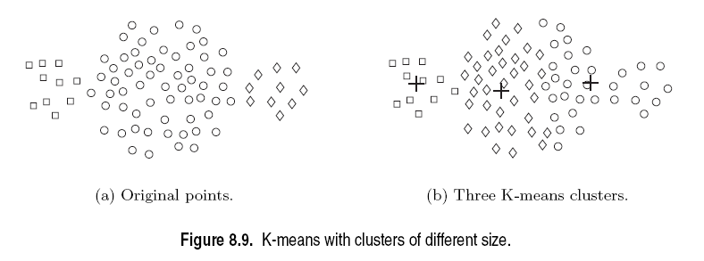

In Figure 8.9, K-means cannot find the three natural clusters.

Because one of the clusters is much larger than the other two, and hence, the larger cluster is broken, while one of the smaller clusters is combined with a portion of the larger cluster.

In Figure 8.10, K-means fails to find the three natural clusters because the two smaller clusters are much denser than the larger cluster.

In Figure 8.11, K-means finds two clusters that mix portions of the two natural clusters because the shape of the natural clusters is not globular.

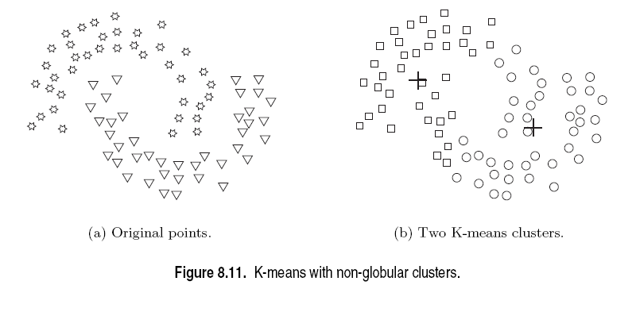
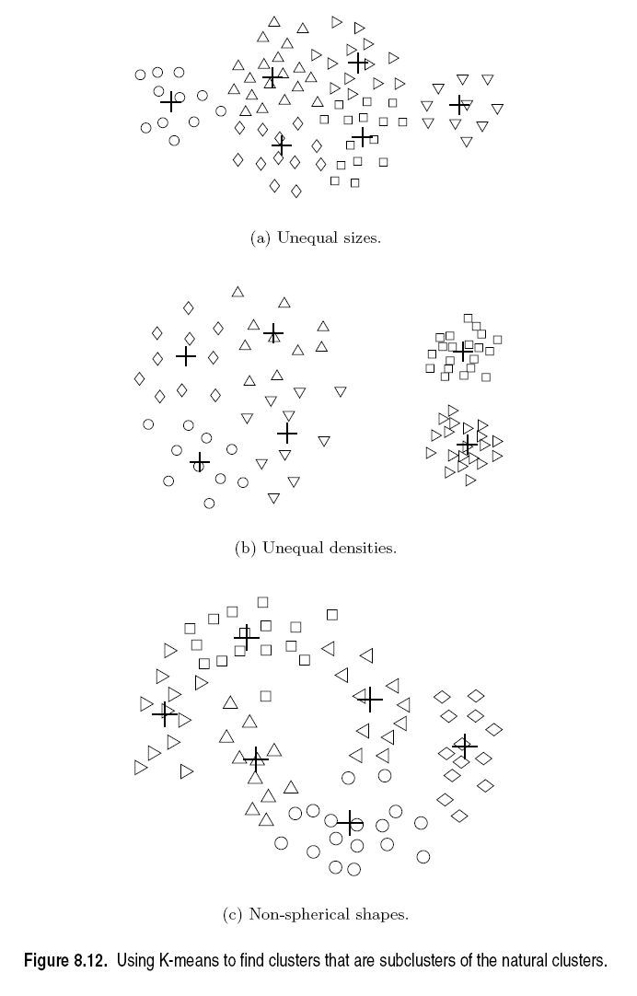
These limitations can be overcome, a clustering that breaks the natural clusters into a number of sub-clusters.

Figure 8.12 shows what happens to the three previous data sets if we find six clusters instead of two or three.

Each smaller cluster is pure in the sense that it contains only points from one of the natural clusters.

The difficulty in these three situations is that the K-means objective function is a mismatch for finding the kinds of clusters we are trying.

Because it is minimized by globular clusters of equal size and density or by clusters that are well separated.

Topic: Strengths and Weaknesses:
Strengths

- K-means is simple and can be used for a wide variety of data types.
- It is also quite efficient, even though multiple runs are often performed.
- Some variants, including bisecting K-means, are even more efficient, and are less susceptible to initialization problems.
- It can typically find pure sub-clusters if a large enough number of clusters is specified.

Weaknesses

- K-means is not suitable for all types of data.
- It cannot handle non-globular clusters or clusters of different sizes and densities.
- K-means also has trouble clustering data that contains outliers. Outlier detection and removal can help significantly in such situations.

Topic: K-means as an Optimization Problem:

This concept includes the mathematics behind K-means.

An objective function such as “minimize SSE,” clustering can be treated as an optimization problem.

One way to solve this problem is to find a global optimum, which is to enumerate all possible ways of dividing the points into clusters.

And then choose the set of clusters that best satisfies the objective function, e.g., that minimizes the total SSE.

- Derivation of K-means as an Algorithm to Minimize the SSE

Here, we show how the centroid for the K-means algorithm can be mathematically derived when the proximity function is Euclidean distance and the objective is to minimize the SSE.

How we can best update a cluster centroid so that the cluster SSE is minimized. In mathematical terms, we seek to minimize Equation, specialized for one-dimensional data is:

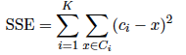

Here, C_{i} is the i^{th} cluster, x is a point in C_{i} , and c_{i} is the mean of the i^{th} cluster.

We can solve for the k^{th} centroid c_{k} which minimizes Equation by differentiating the SSE, setting it equal to 0, and solving, as indicated below:

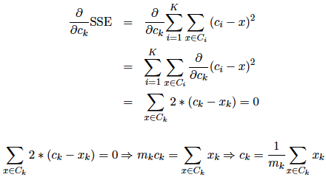

The best centroid for minimizing the SSE of a cluster is the mean of the points in the cluster.

- Derivation of K-means for SAE:

K-means algorithm can be applied to a variety of different objective functions. Here we consider how to partition the data into K clusters.

Such that the sum of the Manhattan (L₁) distances of points from the center of their clusters is minimized.

We are seeking to minimize the sum of the L₁ absolute errors (SAE) as given by the following equation:

Where: Dist _{L1} is the distance of L1.
Again, for notational simplicity, we use one-dimensional data, i.e. dist _{L1}= | c_{i} – x | .

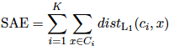
We can solve for the k^{th} centroid c_{k} which minimizes Equation by differentiating the SAE, setting it equal to 0, and solving, as indicated below:
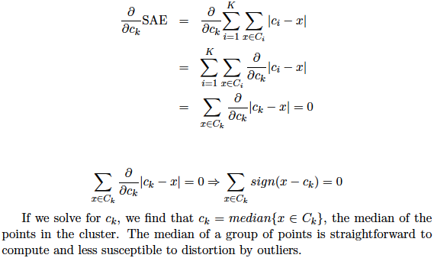

Topic: Agglomerative Hierarchical Clustering:
Hierarchical clustering techniques are a second important category of clustering methods.

These approaches are relatively old compared to many clustering algorithms, but they still in widespread use.

There are two basic approaches for generating a hierarchical clustering:

- Agglomerative hierarchical clustering:

It starts with the points as individual clusters and, at each step and merges the closest pair of clusters.

This requires defining a notion of cluster proximity.

Agglomerative hierarchical clustering techniques are the most common techniques; here we will focus exclusively on these methods.

- Divisive hierarchical clustering :

It Start with one, all-inclusive cluster and, at each step, split a cluster until only singleton clusters of individual points remain.

In this case, we need to decide which cluster to split at each step and how to do the splitting.

A hierarchical clustering is often displayed graphically using a tree-like diagram called a dendrogram.

This displays both the cluster and sub-cluster relationships. It also displays the order in which the clusters were merged in agglomerative view or split in divisive view.

A hierarchical clustering can also be graphically represented using a nested cluster diagram.

The Figure shows an example of these two types of figures for a set of four two-dimensional points.

These points were clustered using the single-link technique.

Topic: Basic Agglomerative Hierarchical Clustering Algorithm:

Many agglomerative hierarchical clustering techniques are variations on a single approach:

Starting with individual points as clusters, successively merge the two closest clusters until only one cluster remains.

This approach is expressed more formally in Algorithm:

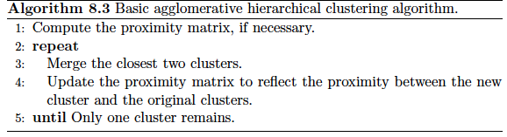

The key operation of Algorithm is the computation of the proximity between two clusters.

It is the definition of cluster proximity that differentiates the various agglomerative hierarchical techniques.

Cluster proximity is typically defined with a particular type of cluster in mind. Different definitions of cluster proximity are more natural.

If we take graph-based view of clusters:

For example, many agglomerative hierarchical clustering techniques, such as MIN, MAX, and Group Average, come from a graph-based view of clusters.

MIN defines cluster proximity as the proximity between the closest two points that are in different clusters, or using graph terms, the shortest edge between two nodes in different subsets of nodes.

MAX takes the proximity between the farthest two points in different clusters to be the cluster proximity, or using graph terms, the longest edge between two nodes in different subsets of nodes.

Group average technique, defines cluster proximity to be the average pair wise proximities (average length of edges) of all pairs of points from different clusters.

If, we take a prototype-based view, in which each cluster is represented by a centroid.

When using centroids, the cluster proximity is commonly defined as the proximity between cluster centroids.

An alternative technique, Ward’s method, also assumes that a cluster is represented by its centroid.

Like K-means, Ward’s method attempts to minimize the sum of the squared distances of points from their cluster centroids.

Time and Space Complexity:

The basic agglomerative hierarchical clustering algorithm just presented uses a proximity matrix.

This requires the storage of “ ½ m^{2 “}, where m is the number of data points.

The space needed to keep track of the clusters is proportional to the number of clusters, which is “ m-1 ”.

Hence, the total space complexity is O(m²).

The additional complexity of keeping data in a sorted list or heap, the overall time required for a hierarchical clustering based on Algorithm 8.3 is O(m log m²).

The space and time complexity of hierarchical clustering severely limits the size of data sets that can be processed.

Topic: Specific Techniques:

- Sample Data

To illustrate the behavior of the various hierarchical clustering algorithms, we shall use sample data that consists of 6 two-dimensional points, which are shown in Figure.

The x and y coordinates of the points and the Euclidean distances between them are shown in Tables.

- Single Link or MIN

For the single link or MIN version of hierarchical clustering, the proximity of two clusters is defined as the minimum of the distance (maximum of the similarity) between any two points in the two different clusters.

Using graph terminology, if you start with all points as singleton clusters and add links between points one at a time, shortest links first, then these single links combine the points into clusters.

Example on Single Link:

The following Figure 8.16 shows the result of applying the single link technique to our example data set of six points.

Figure 8.16(a) shows the nested clusters as a sequence of nested ellipses, where the numbers associated with the ellipses indicate the order of the clustering.

Figure 8.16(b) shows the same information, but as a dendrogram.

The height at which two clusters are merged in the dendrogram reflects the distance of the two clusters.

The distance between points 3 and 6 is 0.11, and that is the height at which they are joined into one cluster in the dendrogram.

As another example:

The distance between clusters {3,6} and{2, 5} is given by

dist({3, 6},{2, 5}) = min(dist(3, 2),dist(6, 2),dist(3, 5),dist(6, 5))
= min(0.15,0.25, 0.28, 0.39)
= 0.15.

- Complete Link or MAX or CLIQUE:

For the complete link or MAX version of hierarchical clustering, the proximity of two clusters is defined as the maximum of the distance (minimum of the similarity) between any two points in the two different clusters.

Using graph terminology, if you start with all points as singleton clusters and add links between points one at a time, shortest links first, then a group of points is not a cluster until all the points in it are completely linked to form a clique.

Complete link is less susceptible to noise and outliers, but it can break large clusters and it favors globular shapes.
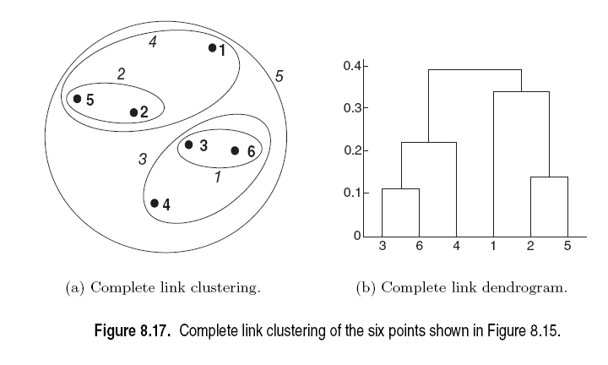

Example Complete Link:

Figure 8.17 shows the results of applying MAX to the sample data set of six points.

As with single link, points 3 and 6 are merged first. However, {3, 6} is merged with {4}, instead of {2, 5} or {1} because:

dist({3, 6}, {4}) = max(dist(3, 4),dist(6, 4))
= max(0.15,0.22)
= 0.22.

dist({3, 6}, {2, 5}) =max(dist(3, 2),dist(6, 2),dist(3,5),dist(6, 5))
= max(0.15,0.25, 0.28, 0.39)
=0.39.

dist({3, 6}, {1}) =max(dist(3, 1),dist(6, 1))
= max(0.22,0.23)
=0.23.

- Group Average:

For the group average version of hierarchical clustering, the proximity of two clusters is defined as the average pair-wise proximity among all pairs of points in the different clusters.

This is an intermediate approach between the single and complete link approaches.

Thus, for group average, the cluster proximity:

Proximity (C_{i}, C_{j}) of clusters C_{i} and C_{j}, which are of size m_{i} and m_{j} is expressed by the following equation:

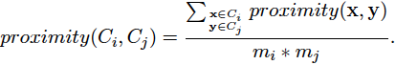

Example on Group Average: Figure 8.18 shows the results of applying the group average approach to the sample data set of six points.

The group average calculate the distance between some clusters.

dist({3, 6, 4}, {1}) = (0.22 + 0.37 + 0.23)/(3 * 1)
= 0.28

dist({2, 5}, {1}) = (0.2357 + 0.3421)/(2 * 1)
= 0.2889

dist({3, 6, 4}, {2, 5}) = (0.15 + 0.28 + 0.25 + 0.39 + 0.20 + 0.29)/(6 * 2)
= 0.26

Because dist({3, 6, 4}, {2, 5}) is smaller than dist({3, 6, 4}, {1}) and dist({2,5}, {1}), clusters {3, 6, 4} and {2, 5} are merged at the fourth stage.

Topic: Ward’s Method and Centroid Methods

For Ward’s method, the proximity between two clusters is defined as the increase in the squared error that results when two clusters are merged.

Thus, this method uses the same objective function as K-means clustering.

Because, this Ward’s method somewhat distinct from other hierarchical techniques.

It can be shown mathematically that Ward’s method is very similar to the group average method when the proximity between two points is taken to be the square of the distance between them.

Example on Ward’s Method:

Figure 8.19 shows the results of applying Ward’s method to the sample data set of six points.

This produced clustering is different from those produced by single link, complete link, and
Group average.

Ward’s method is the correct hierarchical analog.
Centroid Method

Centroid methods calculate the proximity between two clusters by calculating the distance between the centroids of clusters.

These techniques may seem similar to K-means, but as we have remarked.

Centroid methods also have a characteristic. It is often considered bad. But that is not possessed by the other hierarchical clustering techniques.

The possibility of inversions.

Specifically, two clusters that are merged may be more similar (less distant) than the pair of clusters that were merged.

Topic: The Lance-Williams Formula for Cluster Proximity:

The Lance-Williams formula shown below in Equation:

This Equation is the proximity between the clusters R and Q.

R is formed by merging clusters A and B.

In this equation, p(.,.) is a proximity function, while m_{A}, m_{B} and m_{Q} are the number of points in clusters A, B, and Q.

After we merge clusters A and B to form cluster R, the proximity of the new cluster, R to an existing cluster, Q, is a linear function.

This linear function with the proximities of Q with respect to the original clusters A and B.

Table shows the values of these coefficients for the techniques:

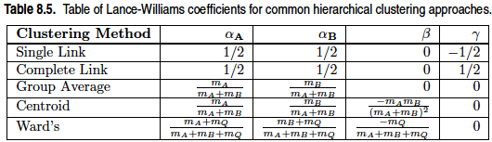

Any hierarchical clustering technique that can be expressed using the Lance-Williams formula.

By using this formula they do not need to keep the original data points.
Topic: Key Issues in Hierarchical Clustering:

There are 3 key issues related to the Hierarchical clustering:

- Lack of a Global Objective Function.
- Ability to Handle Different Cluster Sizes.
- Merging Decisions Are Final.

Lack of a Global Objective Function:

Agglomerative hierarchical clustering cannot be viewed as globally optimizing an objective function.

Agglomerative hierarchical clustering techniques use various criteria to decide locally at each step, which clusters should be merged or split for divisive approaches.

That means, Agglomerative hierarchical clustering algorithms tend to make good local decisions about combining two clusters.

Ability to Handle Different Cluster Sizes:

There are two approaches:
- Weighted , which treats all clusters equally.
- Un-weighted , which takes the number of points in each cluster into account.

Note that the terminology of weighted or un-weighted refers to the data points, not the clusters.

Merging Decisions Are Final:

Agglomerative hierarchical clustering algorithms tend to make good local decisions about combining two clusters, since they can use information about the pair-wise similarity of all points.

However, once a decision is made to merge two clusters, it cannot be undone at a later time.

This approach prevents a local optimization criterion from becoming a global optimization criterion.

Topic: Strengths and Weaknesses:

- These algorithms can produce better-quality clusters.

- Agglomerative hierarchical clustering algorithms are expensive in terms of their computational and storage requirements.

- The fact that all merges are final can also cause trouble for noisy, high-dimensional data, such as document data.
Topic: DBSCAN:

Density-based spatial clustering of applications with noise (DBSCAN) is a data clustering algorithm.

DBSCAN is a simple and effective density-based clustering algorithm that illustrates a number of important concepts that are important for any density-based clustering approach.

Here we focus only on DBSCAN the key notion of “Density”.

Density-based clustering locates regions of high density that are separated from one another by regions of low density.

- Traditional Density: Center-Based Approach:

In the center-based approach, density is estimated for a particular point in the data set.

It also counts the number of points within a specified radius, Eps, of that point. This includes the point itself.

This technique is graphically illustrated by Figure 8.20. The number of points within a radius of Eps of point A is 7, including A itself.
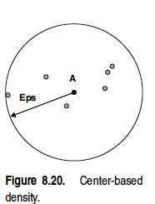

This method is simple to implement, but the density of any point will depend on the specified radius.

For instance, if the radius is large enough, then all points will have a density of m, the number of points in the data set.

Likewise, if the radius is too small, then all points will have a density of 1.

- Classification of Points According to Center-Based Density:

The center-based approach to density allows us to classify a point as being:
- In the interior (inside) of a dense region (a core point).
- On the edge of a dense region (a border point).
- In a sparsely occupied region (a noise or background point).

Figure 8.21 graphically illustrates the concepts of core, border, and noise points using a collection of two-dimensional points.

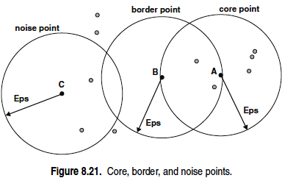
Core points:

These points are in the interior of a density-based cluster.

A point is a core point if the number of points within a given neighborhood around the point as determined by the distance function and a user specified distance parameter, Eps, exceeds a certain threshold, M inPts, which is also a user-specified parameter.

In Figure 8.21, point A is a core point, for the indicated radius (Eps) if M in Pts = 7.

Border points:

A border point is not a core point, but falls within the neighborhood of a core point.

In Figure 8.21, point B is a border point.

Any border point can fall within the neighborhoods of several core points.

Noise points:

A noise point is any point that is neither a core point nor a border point. In Figure 8.21, point C is a noise point.

Topic: The DBSCAN Algorithm:

The DBSCAN algorithm can be informally described as follows:

- Any two core points that are close enough within a distance Eps of one another, are put in the same cluster.

- Likewise, any border point that is close enough to a core point is put in the same cluster like as the core point.

- Noise points are discarded.

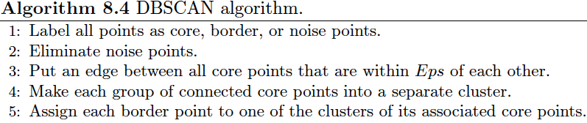

- Time and Space Complexity:

The basic time complexity of the DBSCAN algorithm is:

O (m × time to find points in the Eps-neighborhood), where m is the number of points.

In the worst case, this complexity is O(m²). For, low-dimensional spaces the time complexity can be as low as O(m log m).

The space requirement of DBSCAN even for high-dimensional data, is O(m).

Because it is only necessary to keep a small amount of data for each point, i.e., the cluster label and the identification of each point as a core, border, or noise point.

- Selection of DBSCAN Parameters:

The parameters are Eps and MinPts.

The basic approach is to look at the distance from a point to its k^{th} nearest neighbor, which we will call as the k-dist.

For points that are not in a cluster, such as noise points, the k-dist will be relatively large.

Therefore, if we compute the k-dist for all the data points for some k, sort them in increasing order, and then plot the sorted values, here we expect to see a sharp change at the value of k-dist that corresponds to a suitable value of Eps.

If we select this distance as the Eps parameter and take the value of k as the MinPts parameter:

Then points for which k-dist is less than Eps will be labeled as core points, while other points will be labeled as noise or border points.

- Clusters of Varying Density:

There will be some variation, depending on the density of the cluster. DBSCAN can have trouble with density if the density of clusters varies widely.

Consider Figure, which shows four clusters embedded in noise.

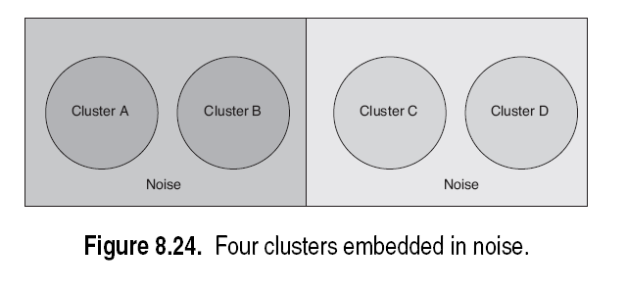

The density of the clusters and noise regions is indicated by their darkness.

The noise around the pair of denser clusters, A and B, has the same density as clusters C and D.

If the Eps threshold is low enough that DBSCAN finds C and D as clusters, then A and B and the points surrounding them will become a single cluster.

If the Eps threshold is high enough that DBSCAN finds A and B as separate clusters, and the points surrounding them are marked as noise, then C and D and the points surrounding them will also be marked as noise.

Topic: Strengths and Weaknesses:

- It is relatively resistant to noise and can handle clusters of arbitrary shapes and sizes.
- DBSCAN can find many clusters that could not be found using K-means.

- DBSCAN has trouble when the clusters have widely varying densities.

- It also has trouble with high-dimensional data because density is more difficult to define for high-dimensional data.

- Finally, DBSCAN can be expensive when the computation of nearest neighbors requires computing all pair-wise proximities, as is usually the case for high-dimensional data.

